SYSTEM DESIGN DOCUMENT
- Introduction
The “Language Learning App with Object Recognition” is a mobile application designed to improve vocabulary skills for language learners, using object recognition technology to display corresponding foreign language words of objects using camera. The system's objectives are to collect a large dataset of images, develop a CNN-based deep learning model for object recognition, and integrate it into the application. The project's success will be determined by the accuracy of the recognition model. The application aims to support multiple languages, have a simple user interface, and provide a responsive user experience.

  - Purpose of the System
The purpose of the “Language Learning App with Object Recognition” is to provide an interactive and engaging platform for language learners to improve their vocabulary skills in a foreign language by using object recognition technology. The application will be useful especially for language learners who has visual memory. The system aims to enhance the user's learning experience by providing a visual aid to learn new words and boost their confidence in using a foreign language.

  - Design Goals
- Learnability: The primary design goal of the project is to help language learners improve their vocabulary skills in a foreign language using an interactive and engaging platform that utilizes object recognition technology.
- Usability: The application should provide a visual aid to learn new words and boost the user's confidence in using a foreign language. It should also have a simple and intuitive UI, be responsive and provide a smooth user experience.
- Develop an efficient deep learning model: The project aims to develop a CNN-based deep learning model that can accurately recognize and classify objects within captured images from camera to enhance the user's learning experience.
- Support multiple languages: The application should be able to support multiple foreign languages to cater to the needs of language learners from different regions.
- Provide a text-to-speech feature: The application should provide a text-to-speech feature to improve the user's pronunciation skills.
- Collect a large dataset of images: The project aims to collect a large dataset of images with common objects from different categories such as fruits, vegetables, animals, and furniture to train the deep learning model.
- Optimize the deep learning model for accuracy and performance: The deep learning model should be optimized for accuracy and performance to ensure that it can accurately recognize and classify objects within images.
  - Definitions, Acronyms, and Abbreviations
Acronyms:

CNN: Convolutional neural network
TTS: Text-to-speech
UI: User interface
UX: User experience
API: Application Programming Interface
SDK: Software Development Kit
GPU: Graphics Processing Unit
CPU: Central Processing Unit

Abbreviations:

App: Application
DL: Deep Learning
UI/UX: User Interface/User Experience
AI: Artificial Intelligence

  - References
https://www.neoito.com/blog/image-recognition-apps/
https://medium.com/@am15hg/real-time-object-detection-using-new-tensorflow-lite-flutter-support-ea41263e801d

- Proposed Software Architecture
- Presentation Layer: This layer consists of the mobile application's user interface, which allows users to interact with the system. The presentation layer uses Flutter, a mobile application development framework, to create the user interface.
- Application Layer: This layer consists of the application logic that processes user requests and communicates with the Deep Learning Model Layer to perform object recognition. The application layer is responsible for capturing images using the mobile device camera, preprocessing the images, sending them to the deep learning model for recognition, and displaying the corresponding foreign language words on the user interface.
- Deep Learning Model Layer: This layer consists of the convolutional neural network-based deep learning model responsible for object recognition and classification. The deep learning model is trained on a large dataset of images with common objects and optimized for accuracy and performance.
- Data Layer: This layer is responsible for storing and managing the dataset of images used for training the deep learning model. The data layer also includes the foreign language vocabulary words that correspond to each object in the dataset.

  - Overview
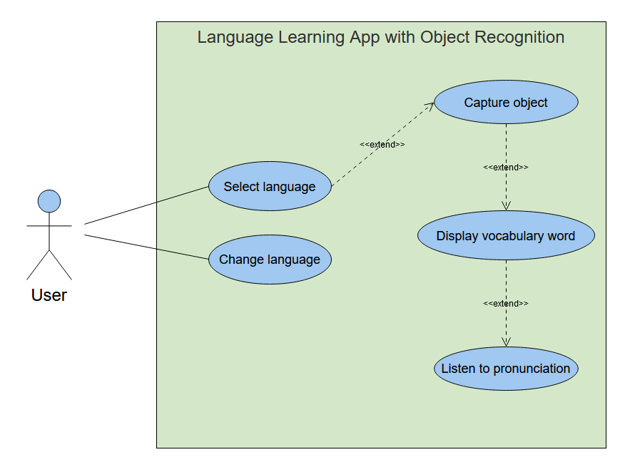
(UML Use Case Diagram)
The software architecture can be divided into two main components: the mobile application built with Flutter, and the machine learning model built with TensorFlow Lite.

The Flutter app will handle the user interface and interaction with the user, while the TensorFlow Lite model will handle the processing of the image data to predict the plant disease.

The Flutter app will consist of several screens, such as a home screen, language selection screen and a camera screen. The home screen will provide basic information about the app, while the camera screen will allow the user to display translation of any object. The app will then pass this image to the TensorFlow Lite model for processing, and the results will be displayed on the results screen.

Since there is no need for user information to be stored, there will be no need for a server or database. The app will only need to store the user's language preference for the duration of the session, which can be achieved using local storage within the app.

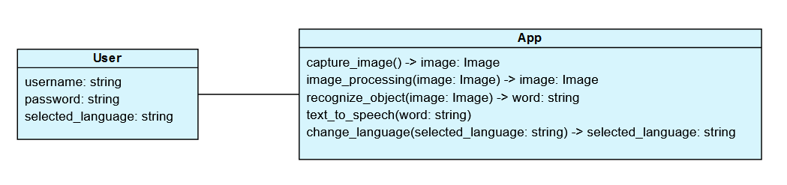
(UML Class Diagram)
  - System Decomposition
- User Interface (UI) Subsystem: This subsystem is responsible for presenting the user interface to the user. It will be developed using Flutter and will include all the necessary screens and widgets to provide a smooth and intuitive user experience. It will also handle user input and will communicate with the Control Subsystem to initiate appropriate actions.
- Control Subsystem: This subsystem is responsible for managing the overall control flow of the application. It will handle all the logical operations and decision-making processes. The Control Subsystem will receive input from the User Interface Subsystem and will interact with the Recognition Subsystem to perform the image recognition tasks. It will also interact with the Translation Subsystem to translate the recognized text to the selected language.
- Recognition Subsystem: This subsystem is responsible for performing the image recognition tasks. It will use TensorFlow Lite to recognize the text from the input image. The Recognition Subsystem will receive input from the Control Subsystem and will return the recognized text to the Control Subsystem.
- Translation Subsystem: This subsystem is responsible for translating the recognized text to the selected language. It will use Google Translate API for performing the translation. The Translation Subsystem will receive input from the Control Subsystem and will return the translated text to the User Interface Subsystem for display.
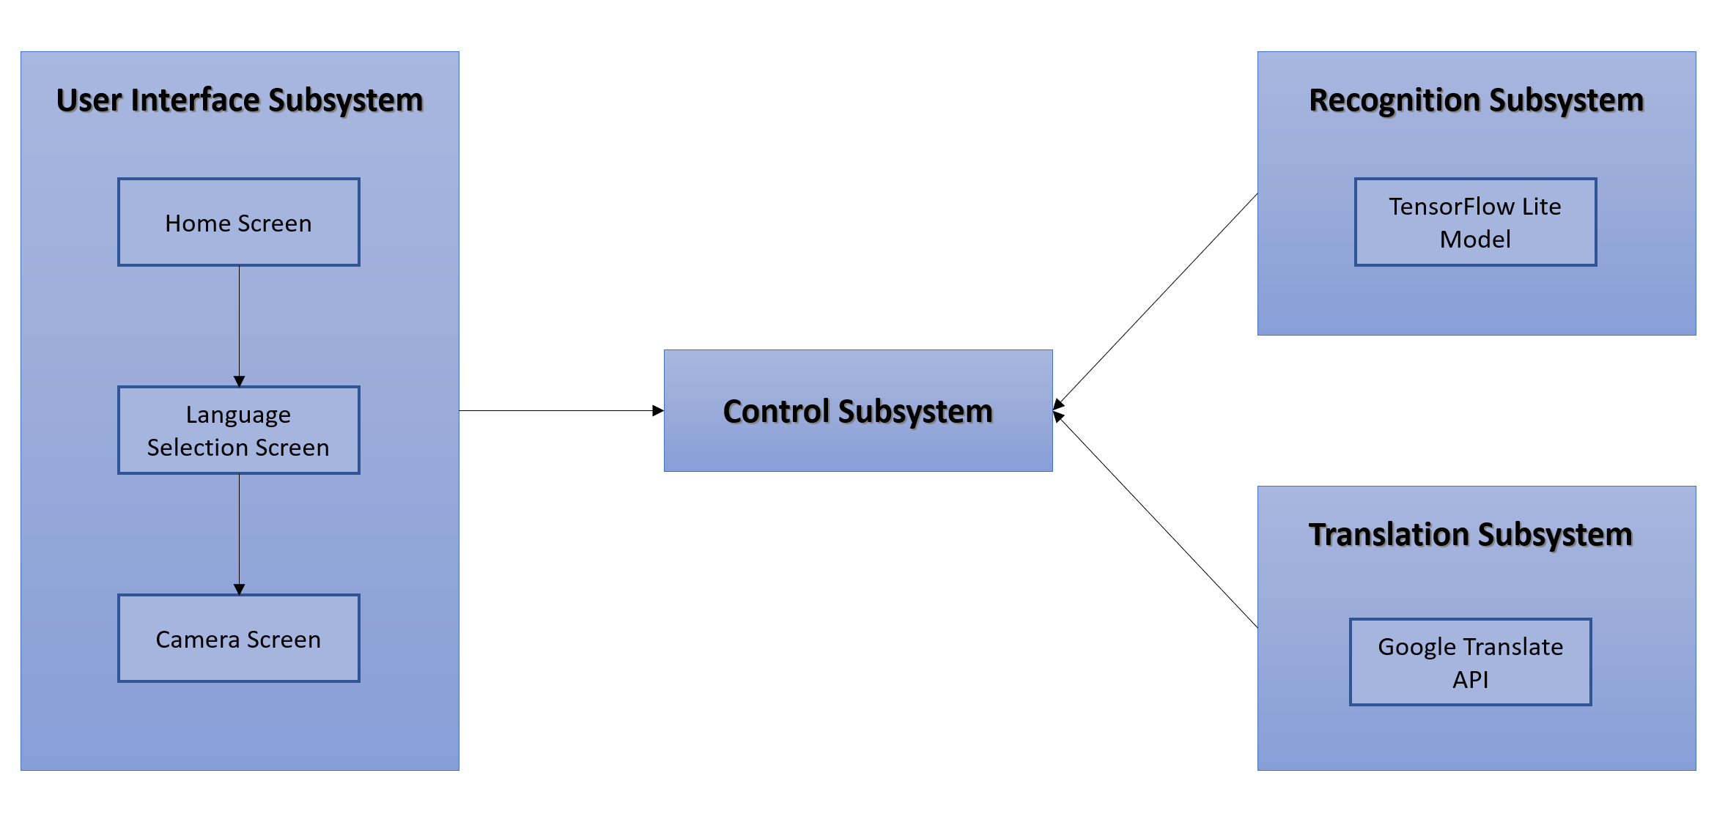
Overall, the subsystems will work together to provide a seamless and efficient user experience. The User Interface Subsystem will interact with the Control Subsystem to initiate the image recognition process, which will then be performed by the Recognition Subsystem using TensorFlow Lite. The recognized text will be sent to the Control Subsystem, which will then interact with the Translation Subsystem to translate the text to the selected language. Finally, the translated text will be sent back to the User Interface Subsystem for display.
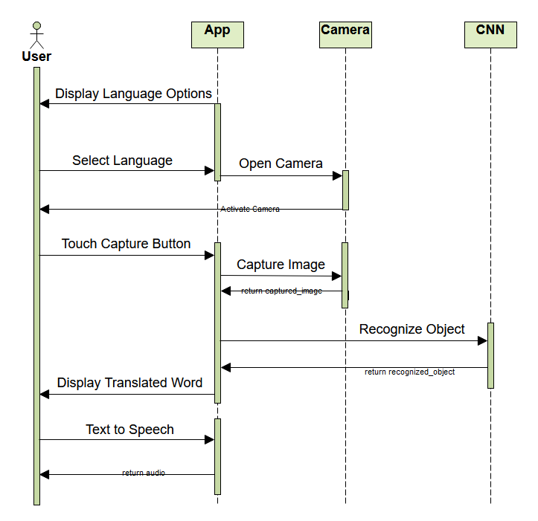
(Sequence Diagram)
  - Hardware/Software Mapping
I will use the following hardware components:
- Mobile device: This will be the primary hardware component on which the mobile application will be installed and work.
- Camera: This will be used to capture images of the objects and translate them into text.
Off-the-shelf components such as the Flutter and TensorFlow Lite will also be used as software. These components provide pre-built solutions for user interface design and image processing, respectively. By using these components, I can save time and reduce the risk of errors in my software development process.
Software reuse can also introduce issues such as compatibility and dependency conflicts. To avoid these issues, I will ensure that all the software components that I will use are compatible with each other and the mobile device's operating system. I will also ensure to only use the latest stable versions of the software components.
  - Persistent Data Management
The system does not require any persistent data storage as it does not collect or store any user data besides the language option that is only stored during a user session. Therefore, there is no need for a database or data management infrastructure.
  - Access Control and Security
The system will have a basic user model that does not require user authentication or authorization. As such, there will be no access matrix or user roles defined.
  - Global Software Control
To implement global software control, the system will use a centralized control mechanism. Requests from the user interface will be initiated through this control mechanism, which will then coordinate with the relevant subsystems to fulfill the request. The subsystems will synchronize their actions with the control mechanism to ensure consistency and avoid conflicts.
  - Boundary Conditions
Constraints:
- The size of the image dataset may affect the performance of the deep learning model.
- The application should be compatible with a wide range of mobile devices and operating systems.
- The development process may require extensive testing and optimization to ensure accurate object recognition and efficient performance.
- The accuracy of the object recognition model may be affected by environmental factors such as lighting and background noise.
- The application may require updates or maintenance to address any bugs or issues that arise during development and usage.
The system has three main boundary conditions: start-up, shutdown, and error behavior.

During start-up, the system initializes the necessary components and resources to run the application. The user is presented with the main menu and can select the desired language option.

During shutdown, the system frees up any resources used during the session and safely terminates the application.

In terms of error behavior, the system is designed to handle errors in a graceful manner. If an unexpected error occurs, the system logs the error and prompts the user to restart the application.

Overall, the system aims to provide a user-friendly and reliable experience while handling any errors that may occur during use.

- Subsystem Services

The "Language Learning App with Object Recognition" system consists of two main components: a mobile application and a deep learning model. The mobile application serves as the user interface, while the deep learning model is responsible for object recognition and classification. The system aims to improve vocabulary skills for language learners by utilizing object recognition technology to display corresponding foreign language words of objects using a camera.

The services provided by each subsystem of the project are:

Mobile Application:
- Capture images of objects using the mobile device camera
- Display the corresponding foreign language vocabulary words for recognized objects
- Allow users to select a foreign language from a list of available languages
- Provide a text-to-speech feature to pronounce the vocabulary words in the selected foreign language
- Have a fast and responsive user interface to provide a smooth user experience
- Be available on both iOS and Android platforms
- Have a simple and intuitive design to be user-friendly
- Be lightweight and not consume too much storage space on the user's device
- Be easy to navigate and intuitive to use, with clear instructions and user guides.

Deep Learning Model:
- Recognize objects from the images using a deep learning model based on convolutional neural networks
- Classify objects into different categories such as fruits, vegetables, animals, and furniture
- Optimize the model for accuracy and performance to ensure that it can accurately recognize and classify objects within images
- Handle a large number of images and vocabulary words.

The success of the project will be determined by the accuracy of the object recognition model and the user's feedback on the application's usability and effectiveness in improving their vocabulary skills. The application should support multiple languages, have a simple and intuitive UI, and provide a smooth and responsive user experience.
- References

